# **Mock Exam 1**

**Date:** 23 June 2023

**Name:** Haffiz

##### Q1

1. A screenshot of a computer

   Description automatically generated
2. A screenshot of a computer

   Description automatically generated
3. A computer screen shot of a program

   Description automatically generated

##### Q2

1. A screenshot of a computer program

   Description automatically generated

##### Q3

1. 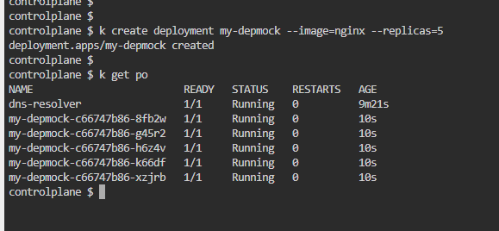

##### Q4

1. A screenshot of a computer

   Description automatically generated

##### Q5

1. A screenshot of a computer program

   Description automatically generated
2. A screenshot of a computer program

   Description automatically generated
3. A screenshot of a computer

   Description automatically generated

##### Q6

1. A screen shot of a computer

   Description automatically generated
2. A screenshot of a computer program

   Description automatically generated

##### Q7

1. 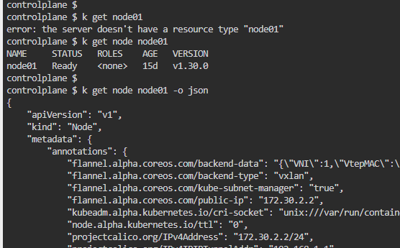

##### Q8

1. A computer screen shot of a black screen

   Description automatically generated

##### Q9

1. A black background with white text

   Description automatically generated

##### Q10

1. A screenshot of a computer

   Description automatically generated
2. A screen shot of a computer

   Description automatically generated A screen shot of a computer

   Description automatically generated

##### Q11

1. A screenshot of a computer

   Description automatically generated
2. A screenshot of a computer

   Description automatically generated
   * Should we label the node to complete the question? thanks

##### Q12

1. A screenshot of a computer

   Description automatically generated
2. A screen shot of a computer

   Description automatically generated
3. A screenshot of a computer program

   Description automatically generated
4. A screenshot of a computer program

   Description automatically generated

##### Q13

1. A screen shot of a computer

   Description automatically generated

##### Q14

1. A screenshot of a computer

   Description automatically generated
2. 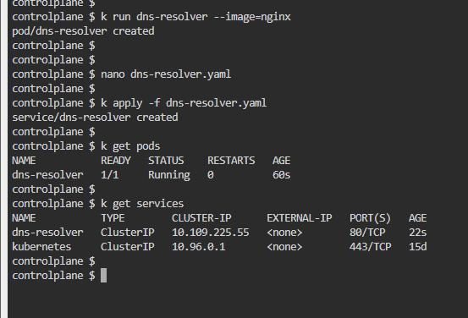

##### Q15

1. A screenshot of a computer

   Description automatically generated